Hardware Design Specification Document

Middlesex University  
Reday Yahya  
M00531154  
01.01.2018

Introduction

This document will specify and inform about hardware design choices and the implementation of hardware for the smart mirror prototype.

For the prototype to be fully working and useful, it will need to fulfil certain factors. These are the factors listed:

* **Portability**  
  One of the main factors is portability. Mirrors are light and portable. They can be almost used anytime and everywhere. Therefore, the smart mirror prototype must also be very portable. This is why the smart mirror prototype will aim to be not bigger than a standard bathroom mirror. Bathroom mirrors usually come with the size of H45 x W60 and this will be size the smart mirror prototype will aim for.
* **Lightness**  
  Besides being portable, the smart mirror prototype should also aim to be light. Lightness is another factor that needs to be considered when choosing hardware. Lightness is important because a heavy mirror will be hard to place and position. A light mirror can be placed and used anywhere. Lightness also plays a minor role for portability.
* **Security**

Since the smart mirror is utilizing electricity and hardware components that utilize electricity, it should be important that the mirror is safe. This project aims to be able to be used everywhere, therefore it should attempt to be secure and should not be the cause of a hazard. In order to make sure that the prototype is secure, hardware components will be coated with protective anti-static plastic and isolating electrical tape.

Scopes:

* Prototype mirror + frame
* Rasberry PI and camera Setup
* LCD Display setup

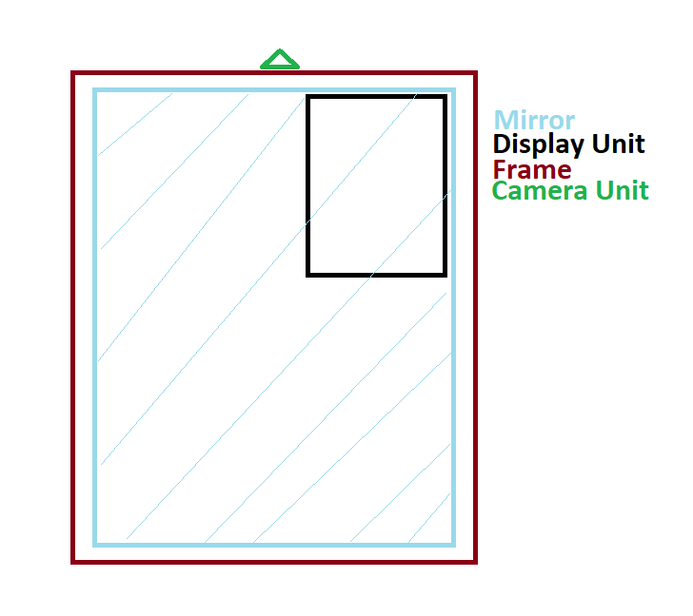Design

This chapter will discuss the design scopes and what is required to have a successful prototype mirror that can work with the software developed.

The first and most important component that is required for the smart mirror prototype is an actual mirror or anything that is capable to act like a mirror. A smart mirror would not be a smart mirror without a reflective interface. The reflective interface is what makes the mirror a mirror. Therefore, anything that can act like a normal mirror or even a working mirror itself should work for this prototype. As the smart mirror would have electrical components installed, it would be a benefit if the mirror component would have room and capacity to hold some components. It would be also much of a benefit if the mirror component would have a frame or something like a frame that would give it some durability. People interact with mirrors and mirrors can break fast and with the added technology added to the smart mirror it simply adds another layer of potential hazards. A frame would act for added security to prevent health and safety hazards and any potential damage to the smart mirror.

Figure 1 Digital Design sketch

The second important component needed would be a set of electrical components that the software can utilize. For the software following components are required:

* Computing Interface
* Camera
* Display Component
* Microphone

For this anything that matches the requirement factors can be utilized. This means that the hardware choices need to be portable, light and secure. Mirrors can be used everywhere and anywhere, therefore a smart mirror should be able to do this too. The electrical components should be hidden behind the reflective component, this includes any wires. The user should simply see the mirror reflection and partly the overlay coming from the display unit.

The next bit of the document is documenting and evaluating design choices.

Mirror and Frame

There are several options that the prototype can use to fulfil the mirror half in “smart mirror”. One way to do this is to simply take a mirror and modify it to be a smart mirror. The benefits of this would be that the mirroring reflective interface would be 1:1 (or what the mirror specifies). One drawback to this would be that the mirror would simply be a mirror and that would mean that the mirror most likely has very less room to install electrical components. Another Drawback to this option would be that the thickness of the reflective coating of the mirror would be so thick, that the electrical display component of the smart mirror would have trouble shining through, which would lead to limited visibility. A workaround for this drawback would be to utilize a one-sided mirror, however these special types of mirrors are high in costs and usually weight more than a regular mirror. As price and usability is limited to this option an alternative design choice has been taken for this project.

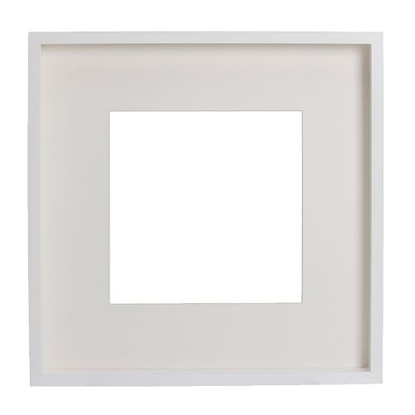

Figure 2"Ribba" by IKEA | Source: <http://www.ikea.com/gb/en/products/decoration/frames-pictures/ribba-frame-white-art-20378440/>

For this Project the mirror has been made through a modified picture frame. The frame used is called “Ribba” and it is made and sold by IKEA. The frame has a W50 x H50, making it an ideal size for it to be placed anywhere. “Ribba” also has a sturdy wooden frame all around making it very sturdy. Inside the frame it offers a lot of room for components to sit inside.

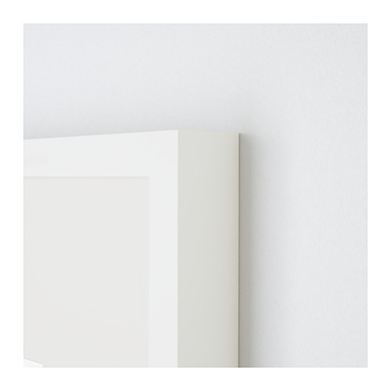

Figure 3 "Ribba" by IKEA | Source: <http://www.ikea.com/gb/en/products/decoration/frames-pictures/ribba-frame-white-art-20378440/>

“Ribba” also comes with a plastic cover at the frontside preventing anything to enter the frame. The only thing missing for “Ribba” to be utilized for the prototype is that “Ribba” is a picture frame and not a mirror, meaning it does not reflect anything like a mirror. Therefore, another reflective component is needed and combine with “Ribba” for it to be used in the prototype. The plastic cover offers a great surface for it to be turned into a mirror, as the cover has already been prepared to be used with the frame.

While the modified version of “Ribba” was covering the mirror and aesthetics, the remaining half of the prototype was not yet installed, the next part of this document will talk about the hardware design and choices that turn “Ribba” into the smart mirror prototype. For the computing hardware required there were two main components needed: A computer or computing interface that allows interaction with the user and a display unit for visual representation.

For the computing hardware there were multiple options available. While looking over options, the above-named factors that shape the project helped deciding. After reviewing two options were available, the Raspberry PI 3 model b and the Arduino. Both options were viable for the project, however for the project the Raspberry PI 3 was more suitable.

Raspberry Pi 3 Setup

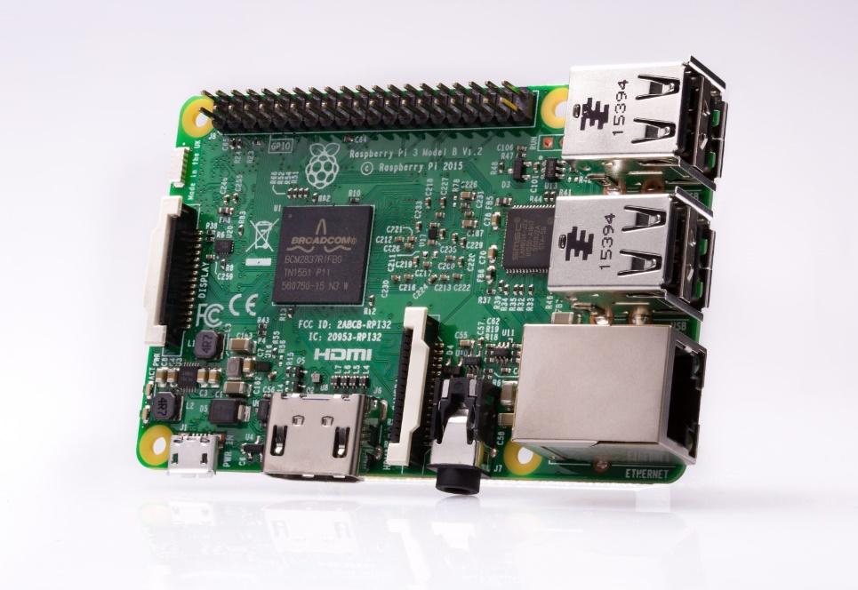

Figure 4 Raspberry Pi 3 | Source: <https://www.raspberrypi.org/products/raspberry-pi-3-model-b/>

The Raspberry Pi 3 [5] was selected for the project.

Hardware:

This minicomputer offered everything the project needed with the added capability of expansion on its board. The core of the raspberry pi 3 is powered by a powerful 1.2 GHz quad-core ARM Cortex A53 (ARMv8 Instruction Set) Central Processing Unit, a Broadcom VideoCore IV @ 400MHz for its GPU and 1GB LPDDR2-900 SDRAM for memory. Besides its core the raspberry pi 3 also offers almost any basic connection port this project needs, from 4 built in USB ports, a HDMI port and an option for gigabit ethernet to wireless interconnectivity methods such built in 802.11n wLAN and Bluetooth 4.0 the raspberry pi 3 covers almost anything. The Raspberry pi 3 also offers connectivity for other electronical components through its 40-pin general purpose input output. For storage the raspberry pi 3 supports any micro SD card. Additionally, a Camera will be needed for the smart mirror. The camera covered will be the raspberry pi 3 v20 camera module, which offers a 1080p picture.

Software:

The raspberry pi 3 was always a very popular choice for software development under minicomputer projects. The hardware offered on the raspberry pi 3 always attracted many developers with minicomputer projects over time and therefore the support for minicomputer software development projects was always very popular and big on the raspberry pi. Companies and Enthusiasts support this platform and for the smart mirror software developed for this project will run also very well on the raspberry pi 3. The raspberry pi 3 supports any operating system that supports the ARMv8 chipset. Special OS have been ported for the raspberry pi 3, such as ubuntu Core, windows 10 and any Linux distro. The raspberry pi 3 also offers its own open source version of Linux “NOOBS” preinstalled on SD cards to be used, which is what the project and prototype will utilize. “NOOBS” will be modified for the needs of this prototype.

LCD Controller Setup

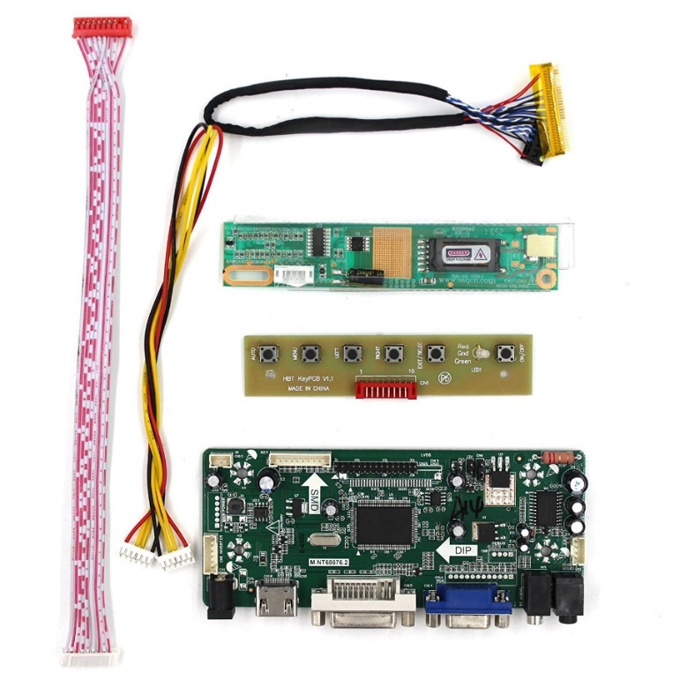The next key component needed for this prototype and project will the display computing unit. For the main requirement, the display unit needs to be suitable for the design factors listed and it needs to be able to be viewed through “Ribba”. For this there were two options available: A full computer display without its cover or a laptop screen. Looking over the design factors, a full computer display was not suitable for this project and prototype. Full computer displays are both heavy and too big and therefore the design choice was to go ahead with a laptop display.

Laptop displays are mainly designed to be used with laptops, however with additional hardware it is possible to make use of laptop displays with the raspberry pi 3. For this task a LCD controller board was required. Controller boards are not something that are marketed and sold directly by the companies. Hardware enthusiasts mainly create them their selves for their own general purpose. Luckily for the Display the projects utilize; a LCD controller board was available for purchase and selected for the project and prototype.

Figure 6 LCD Controller Board for LTN141AT07/2/

The LCD controller board [6] is a set of combined hardware. The main component is the controller board itself. It comes with a 5v input, DVI input, VGA, HDMI and a 3mm headphone jack. On the board there are various chipsets that regulate connection ports as well as graphical output. Connected to the main controller board there are two separate boards. One of them is a small board with buttons. These buttons are made for the display to be controlled. It features a menu button, + button, - button, a power button and a LED light to view if the monitor is on or off. The second board connected to the main connection is a board that focuses on regulating and converting electricity. From this board the LED of the laptop screen will be connected. This board makes sure the LED gets enough voltage required and not too much to overcharge it. The Laptop screen will be connected to the main controller board via a 24 pin LVDS connector cable. The button board and the board that regulates electricity is connected to the main board.

Display Setup

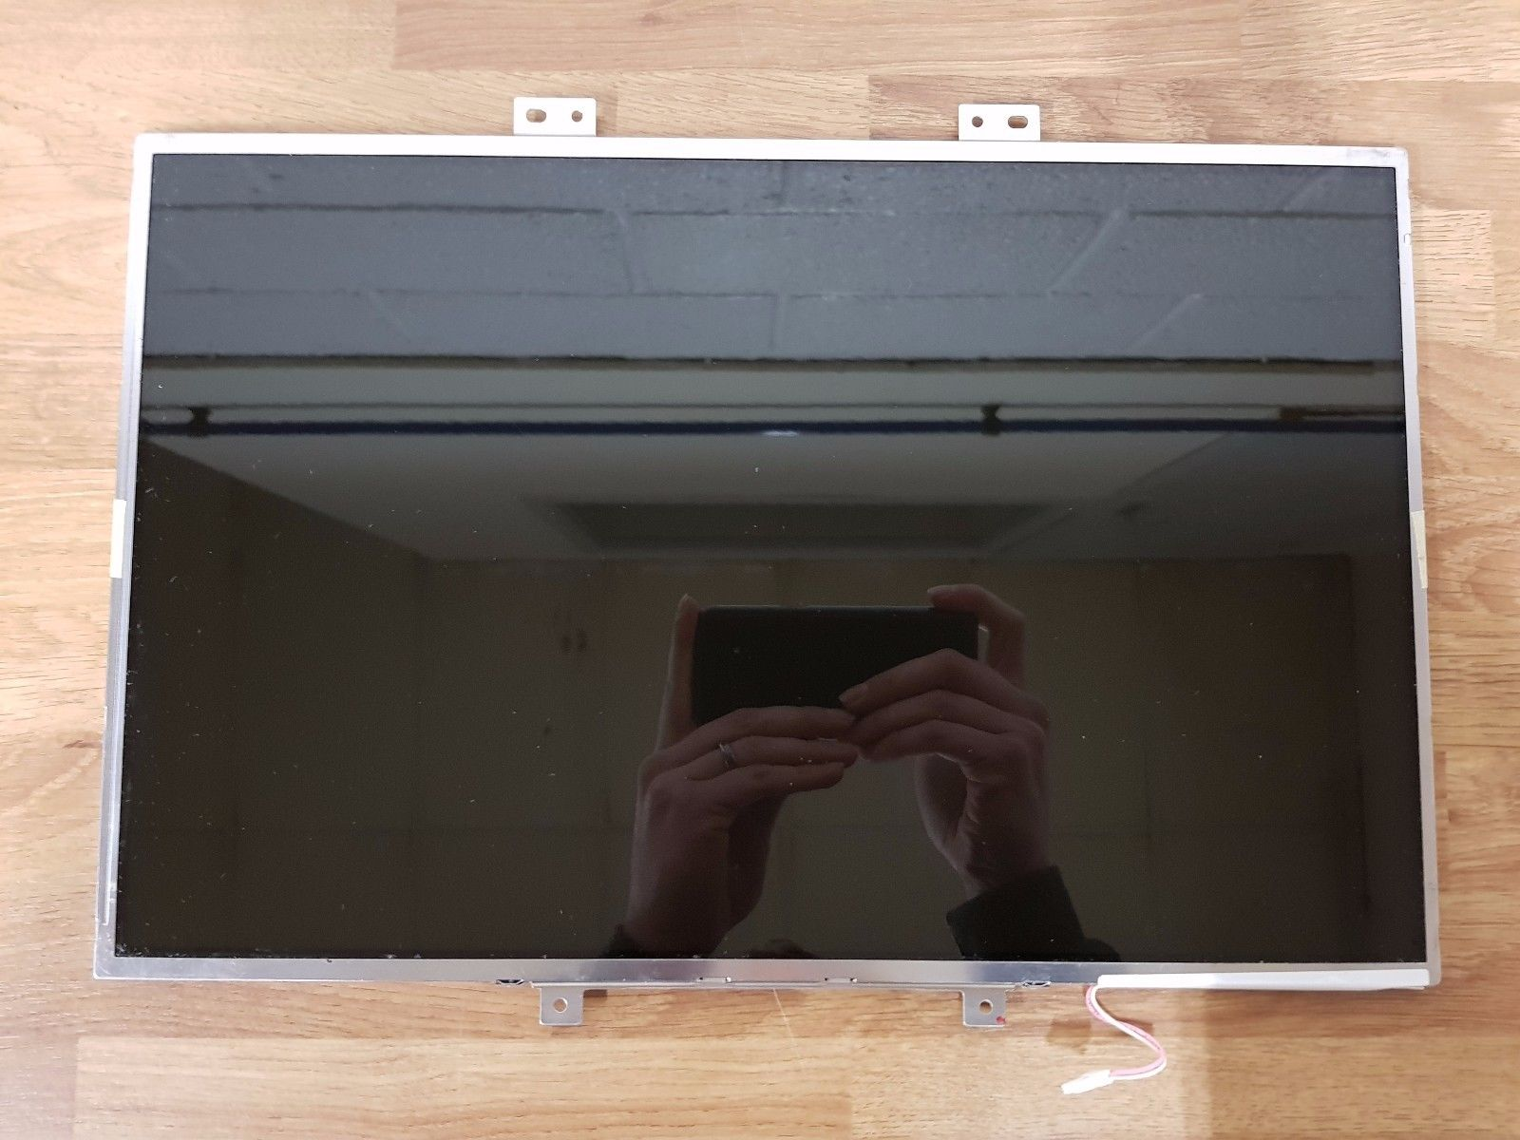

Figure 7 Samsung LTN154X3 - L01

For the laptop screen itself almost anything could’ve been used. For this project prototype specifically, the Samsung LTN154X3 – LO1 has been selected. The Samsung LTN display offers a simple 15.4” LCD display that can be modified. The most important part on why this display is specifically selected is that this display is powered by a powerful backlit white LED in the back. The LED in the back offer high brightness, which is needed in this project to shine the display through mirror in the front. The glass in the front of the display also offers a reflective interface which in addition to the mirror will be beneficial.

Installation and Implementation of Hardware

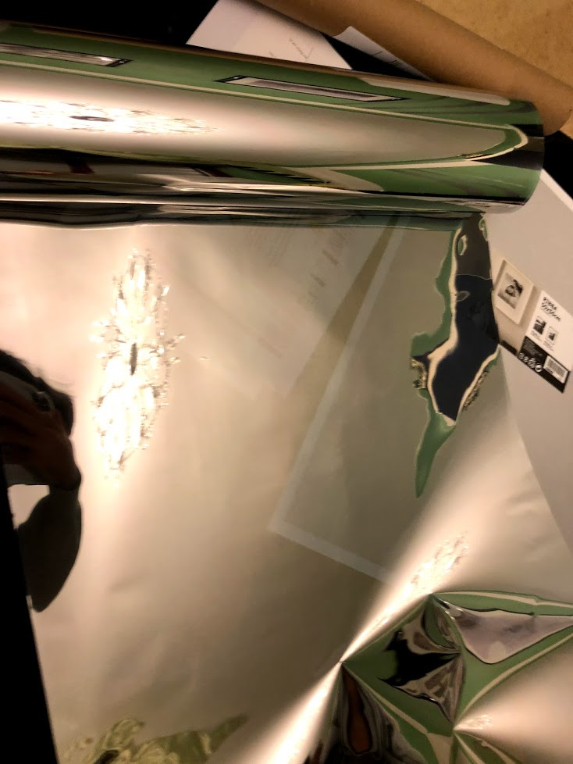

The next and final step for the smart mirror prototype was to combine hardware choices and create the actual prototype. The order on preparing the individual hardware components is not that big of an importance, however it would be of a benefit to start with the frame and mirror first. This is what I have done, I have started on preparing “Ribba”. “Ribba” had no reflective surface as it is a picture frame and not a mirror. Therefore, “Ribba” needed to be modified before it could’ve been used for the smart mirror prototype.

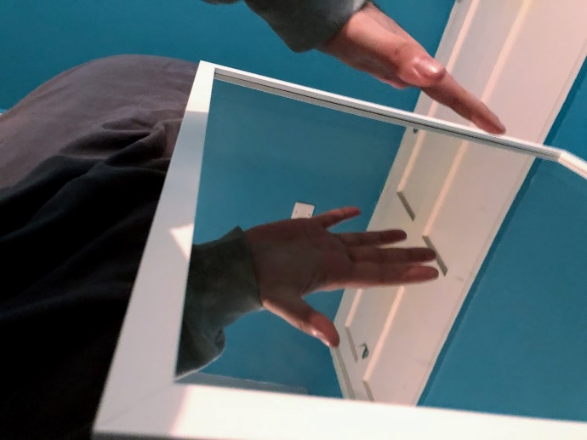Making the plastic cover reflective like a mirror is not a difficult task. For this a special coating is needed to make the picture frame cover reflective. Something like this has been attempted and made, but not for picture frames. Car passenger side windows get additionally coated with reflective coating after purchase. This is where the inspiration for the reflective coating has come from. The idea was to modify the plastic cover of “Ribba” to make it reflective. To make it reflective, the plastic cover of “Ribba” has been covered with a reflective silver window film. The Silver reflective film overlays on top of the plastic cover with a silver layer and the silver reflects anything 1:1 just like a mirror. This combination allowed the project to utilize “Ribba” for the prototype. “Ribba” now is the body of the smart mirror and allows for a safe installation of the smart components to work with the mirror.

Reflective Coating

After installing the plastic panel with the reflective coating, “Ribba” was working exactly like a mirror, making it perfect for the smart mirror prototype. It offers room for the hardware to be installed and the thick wooden border improves security.

Figure 5 modified version of “Ribba" with reflective silver installed

The next task was to add the rest of the electrical components with the modified mirror. This was a slightly difficult task. The first step was to prepare and test the display to work with the additional LVDS converter board. Tested before installation it proofed that the board was working just as intended with the display unit. Once completed with testing of the components, the components needed to be secured. The idea was to cover it with some sort of protection coating. For the project I utilized electrical tape and anti-static electric plastic. The components were attached to the backside of the display unit, due to the fact that the wires were short in length.

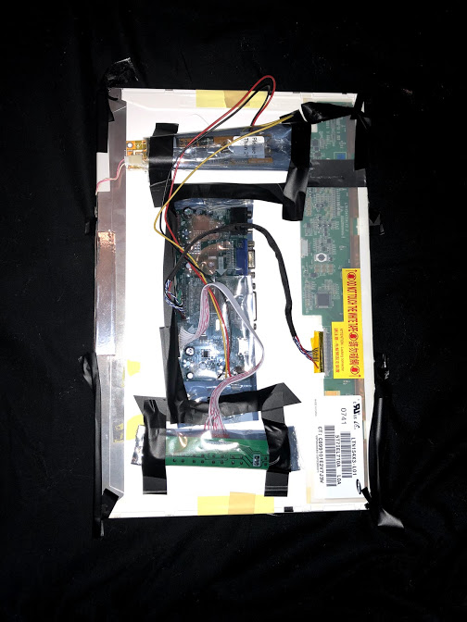

Figure 6 Connected and secured all components

The image in figure 6 shows all components of the display unit connected and together it can now be attached to the backside of the mirror and the raspberry pi 3. During installation to the mirror, there were some complications. The backside of the display was pure LED. As intended because the display needs the strength of the led to shine through the back of the mirror to the front.

However due to the strength of the LED, the backside of the display also illuminated the inside of the frame, making it so reflections are more difficult to see. To overcome this, I simply covered the backside of the plastic panel of “Ribba” with some thick black parchment paper. The only area left out was the frontside of the display. This allowed for only the display area to be illuminated and it also greatly improved lightning of the reflection in low light situations. The additional paper also allowed for an easy installation of the display unit. I used double heavy duty industrial tape attached with some covers to hold the display unit in place. Secured and attached it does not move around at all.

After this the final step was to attach the raspberry pi and the camera unit to the prototype, which would sit inside of “Ribba”. The extra-long wires allowed for a very simple installation right next to the display unit setup completing the final prototype. The prototype is now awaiting software installation.

References

[1] Figure 1: Ribba by Ikea <http://www.ikea.com/gb/en/products/decoration/frames-pictures/ribba-frame-white-art-20378440/>

[2] Silver Reflective Window Film by Aktive Film - <https://www.amazon.co.uk/Silver-Reflective-Film-Control-Privacy/dp/B00GC9AKR6/ref=sr_1_1_sspa?ie=UTF8&qid=1514519368&sr=8-1-spons&keywords=reflective+window+film&psc=1&smid=A379WEJ7K9BTER>

[3] Raspberry Pi 3 model b Specifications - <https://hackaday.com/2016/02/28/introducing-the-raspberry-pi-3/>

[4] Raspberry PI 3 - <https://www.raspberrypi.org/products/raspberry-pi-3-model-b/>

[5] Modified “Ribba” by Reday Yahya

[6] LCD Controller Board <https://www.amazon.co.uk/gp/product/B06XKVTKDH/ref=oh_aui_detailpage_o04_s00?ie=UTF8&psc=1>